See personal doc file for more information:
https://docs.google.com/document/d/1BTpL_2cw7yQkJg1KGG2qokJ33MCvI4Kk-lcf8xF7CTo/edit?tab=t.0

Conceptual Layer
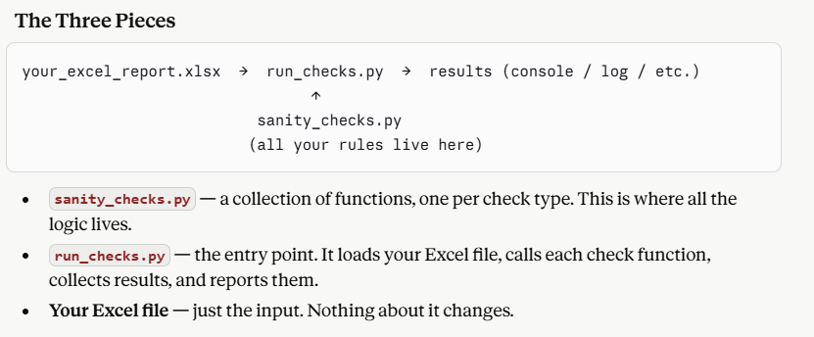
sanity_checks.py (logic)
- Each function does one job
- Runner loops through list of functions and calls each one.
